**SIMPLE IF-ELSE**

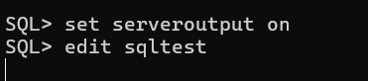

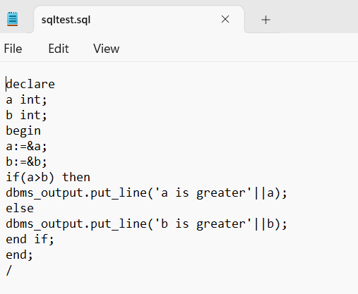

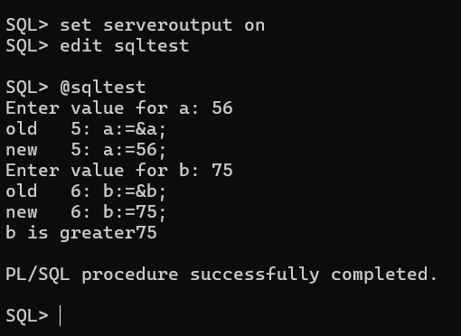

**FETCHING DATA FROM EMPLOYEE TABLE**

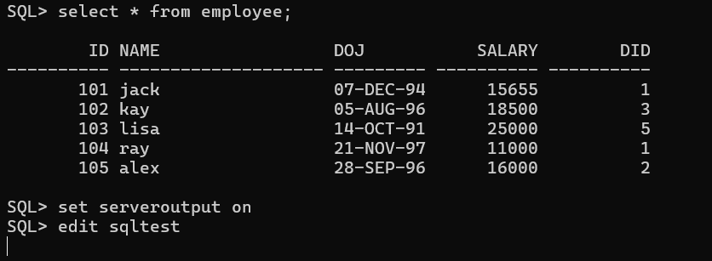

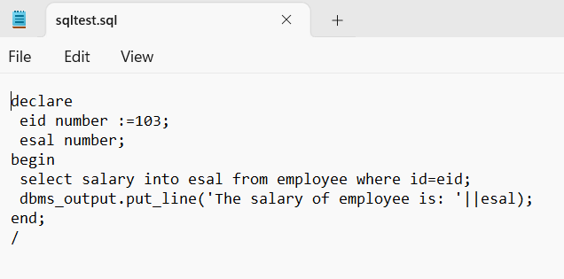

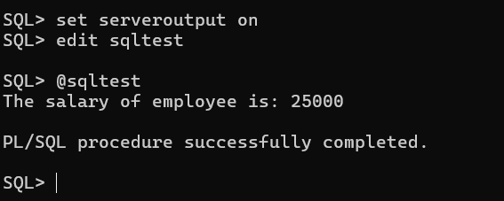

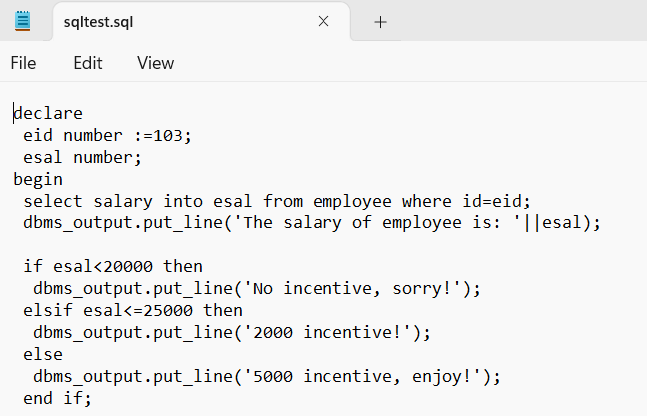

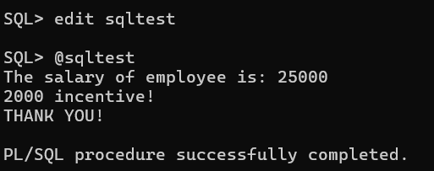

**UPDATE SALARY OF EMPLOYEE TABLE**

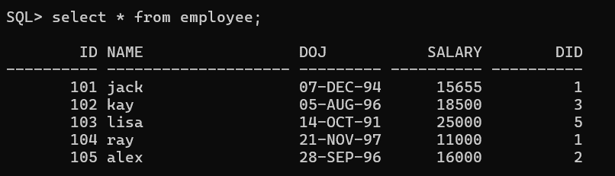

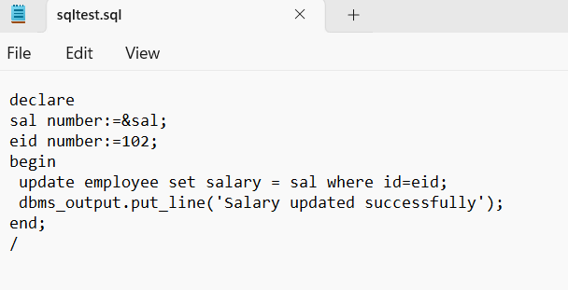

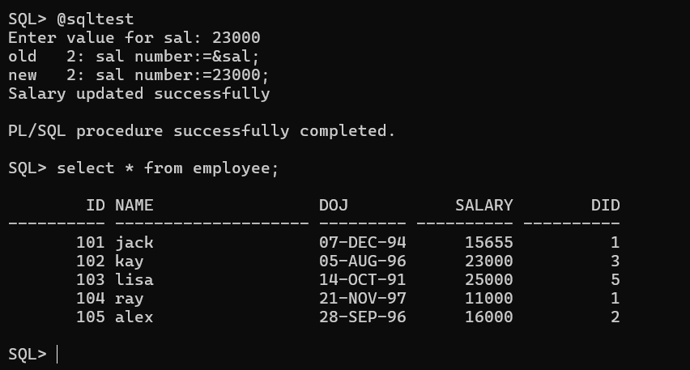

**FETCHING DATA FROM EMPLOYEE WITH LIKE OPERATOR**

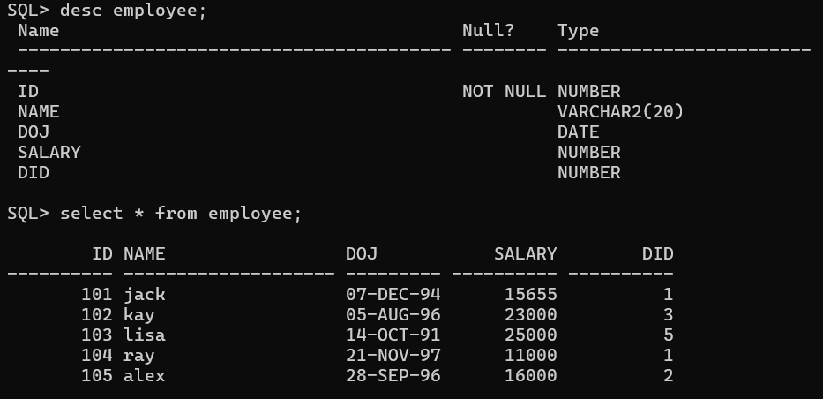

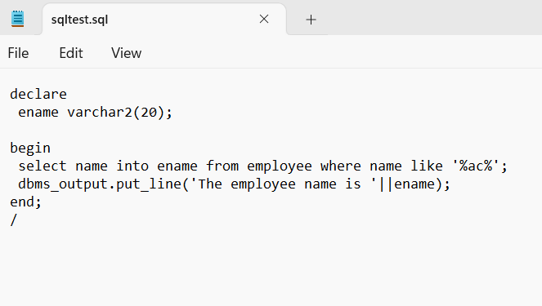

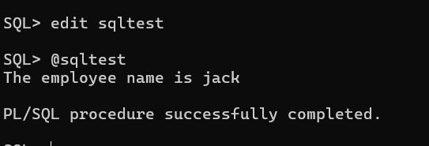

**Write a PL/SQL program to arrange the number of two variable in such a way that the small number will store in num_small variable and large number will store in num_large variable.**

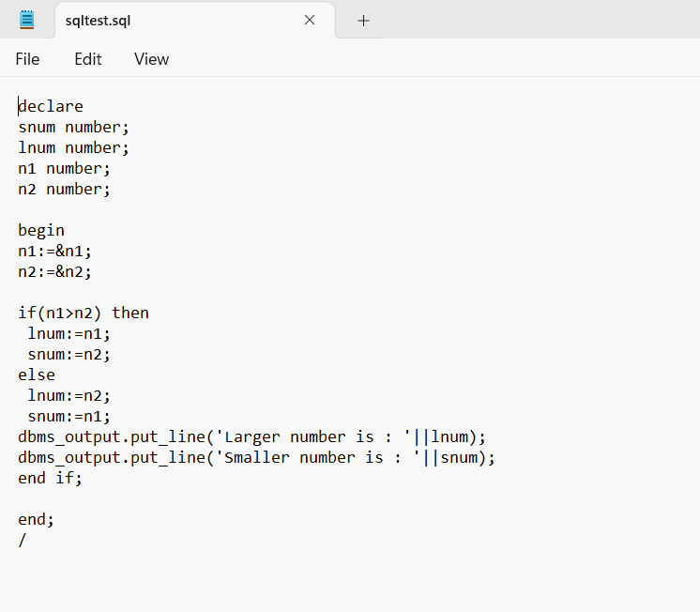

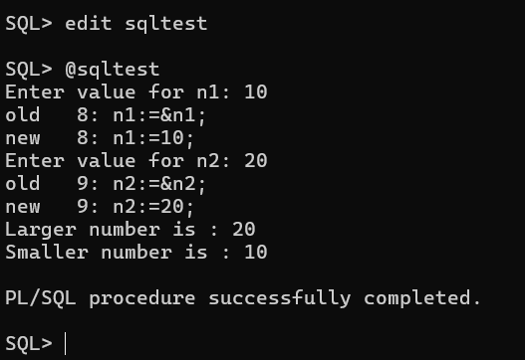

**Write a PL/SQL program to count number of employees in a specific department and check whether this department have any vacancies or not. If any vacancies, how many vacancies are in that department.** 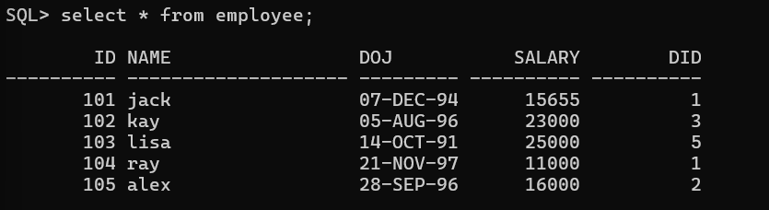

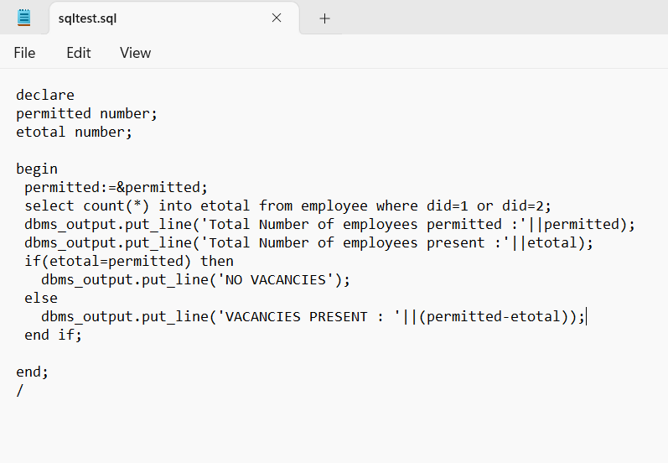

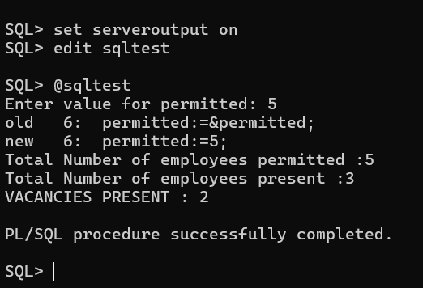

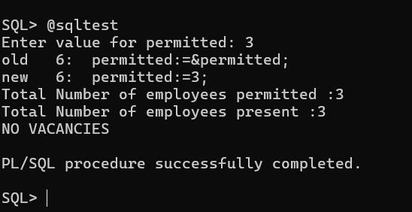

**Write a PL/SQL program to display the employee IDs, names, job titles, hire dates, and salaries of all employees.**

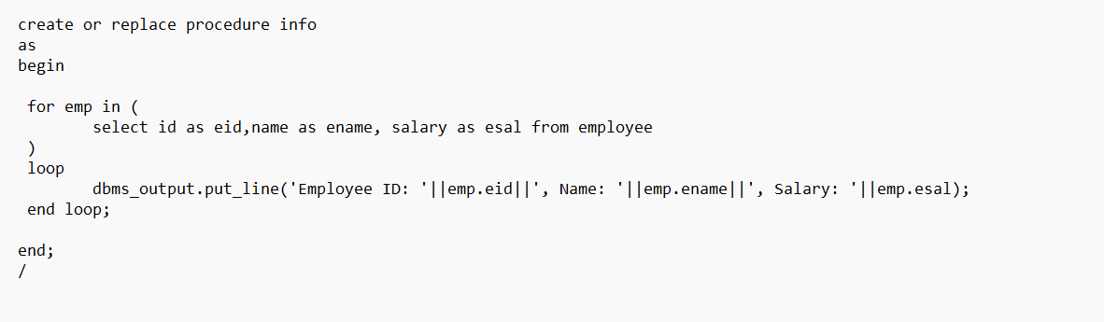

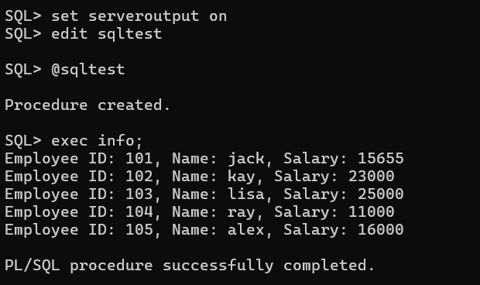

**Write a PL/SQL program to display the employee IDs, names, and department names of all employees.**

